Classifier Improvement Report — Version 2
1. Introduction
Weeks 6 and 7 focused on improving and evaluating the NutriHelp food image classifier through retraining, controlled testing, and stress testing. The goal was not to build a perfect classifier, but to better understand how the model behaves under realistic and challenging conditions such as blurred images, cluttered backgrounds, low lighting, multiple food items, and non-standard camera angles.
By the end of Week 7, a second version of the classifier (Classifier v2) was successfully trained, evaluated, and stress-tested. The outcomes from these experiments provide clear insights into the current limitations of the model and help define a realistic improvement plan for the next trimester.

2. Dataset Improvements (Work from Weeks 4–5)
Before training the new classifier, the dataset underwent significant improvements:
2.1 Balanced Class Distribution
- All 15 food classes were reviewed.
- Missing or underrepresented validation and test samples were added.
- Final counts:
  - Train: 270 images
  - Validation: 52 images
  - Test: 40 images
2.2 Preprocessing Pipeline
A standardised pipeline was created to:
- Convert mixed image formats (PNG, WEBP, JPEG) into consistent JPG
- Resize all images to 224 × 224
- Clean corrupted or unreadable files
- Ensure consistent colour channels (RGB)
2.3 Data Augmentation
To improve generalisation:
- Random rotation
- Horizontal flip
- Brightness adjustments
- Minor perspective variation
This effectively doubled the training set and simulated real-world user photos.
3. Model Architecture (Transfer Learning)
Classifier V2 uses MobileNetV2, a lightweight convolutional neural network suitable for resource-constrained environments like mobile devices.
Why MobileNetV2?
- Efficient and fast on CPU
- Pretrained on ImageNet, allowing strong feature extraction
- Performs well with small to medium datasets
Modifications Made
- Replaced final classification layer with a new fully connected layer for 15 classes
- Enabled training only on later layers ("fine-tuning") to reduce overfitting and training time
- Used:
  - Cross-entropy loss
  - Adam optimizer (learning rate = 0.001)
  - Batch size = 16
  - Epochs = 5

4. Training Results
4.1 Epoch Performance
Epoch | Train Acc | Val Acc | Notes
1 | 0.09 | 0.19 | Initial learning
2 | 0.43 | 0.40 | Strong improvement
3 | 0.57 | 0.42 | Best validation accuracy
4 | 0.61 | 0.40 | Overfitting begins
5 | 0.66 | 0.42 | No further val improvement
Best validation accuracy: 0.4231
A model checkpoint was saved at the best epoch.

5. Test Evaluation
The test dataset (40 images) was used to measure final generalisation performance.
5.1 Overall Accuracy
Test Accuracy = 0.35 (35%)
5.2 Per-Class Accuracy (Selected Observations)
Class | Accuracy | Notes
noodles | 100% | Strong visual features
snacks | 100% | Clear shape boundaries
soup | 100% | Consistent patterns
chicken | 62.5% | Moderately good
rice | 50% | Mixed performance
beef, bread, fruit, lamb, pasta… | 0% | Needs more diversity
5.3 Error Analysis
Most misclassifications occur in:
- Classes with low real variety (e.g., beef images all similar)
- Visually similar categories (e.g., noodles vs pasta)
- Classes with very small test samples, limiting statistical reliability

6. Key Improvements from Version 1 → Version 2
Area | V1 | V2 | Improvement
Dataset | Mixed formats, unbalanced | Clean, balanced, preprocessed | ✔
Augmentation | None | Simple rotation, flip, brightness | ✔
Model | Older architecture | Transfer learning (MobileNetV2) | ✔
Training stability | Poor | Stable with improving curves | ✔
Accuracy | Not provided | 35% (test), 42% (val) | ✔ Moderate
Overall, V2 is a meaningful improvement but still requires more real-world data.

7. Limitations
Despite improvements, some limitations remain:
7.1 Limited Dataset Variety
Artificial augmentation is not a full replacement for genuine images.
7.2 Low Sample Size for Some Classes
Several classes have fewer than 10 real images.
7.3 CPU-based Training
Training on CPU restricts epoch count and deeper fine-tuning.
7.4 Confusable Food Categories
Some dishes visually overlap across classes.

8. Recommendations for Version 3 (Future Work)
A future team—likely in T1 2026—can improve the model using:
8.1 Add More Real Images
Especially for:
- beef
- lamb
- pasta
- seafood
- fruit
Around 20+ per class would significantly increase performance.
8.2 Improve Model Architecture
Try:
- EfficientNet-B0
- ResNet-50
- ViT (Vision Transformers)
8.3 Better Augmentation
Use:
- Cutout
- Color jitter
- Random cropping
8.4 Longer Training
10–20 epochs once GPU resources become available.
8.5 Use Confusion Matrix-Driven Targeting
Identify misclassified pairs and specifically expand those classes.

9. Week 7 – Stress Testing Summary
9.1 Stress Testing Purpose
The objective of stress testing was to simulate real-world user scenarios rather than ideal dataset conditions. Five stress categories were defined, each containing five images:
- Blur
- Cluttered Background
- Low Light
- Multi-Food
- Side Angle
These images were intentionally challenging and not part of the training set. The stress test aimed to observe how confidently and consistently the classifier performs when faced with imperfect inputs.
9.2 Stress Test Setup
A dedicated script (classifier_v2_stress_test.py) was created to:
- Load Classifier v2
- Run inference on each stress category
- Log predicted labels and confidence scores
- Save results to a text file for documentation
All tests were run locally on CPU to ensure reproducibility.
9.3 Stress Test Observations
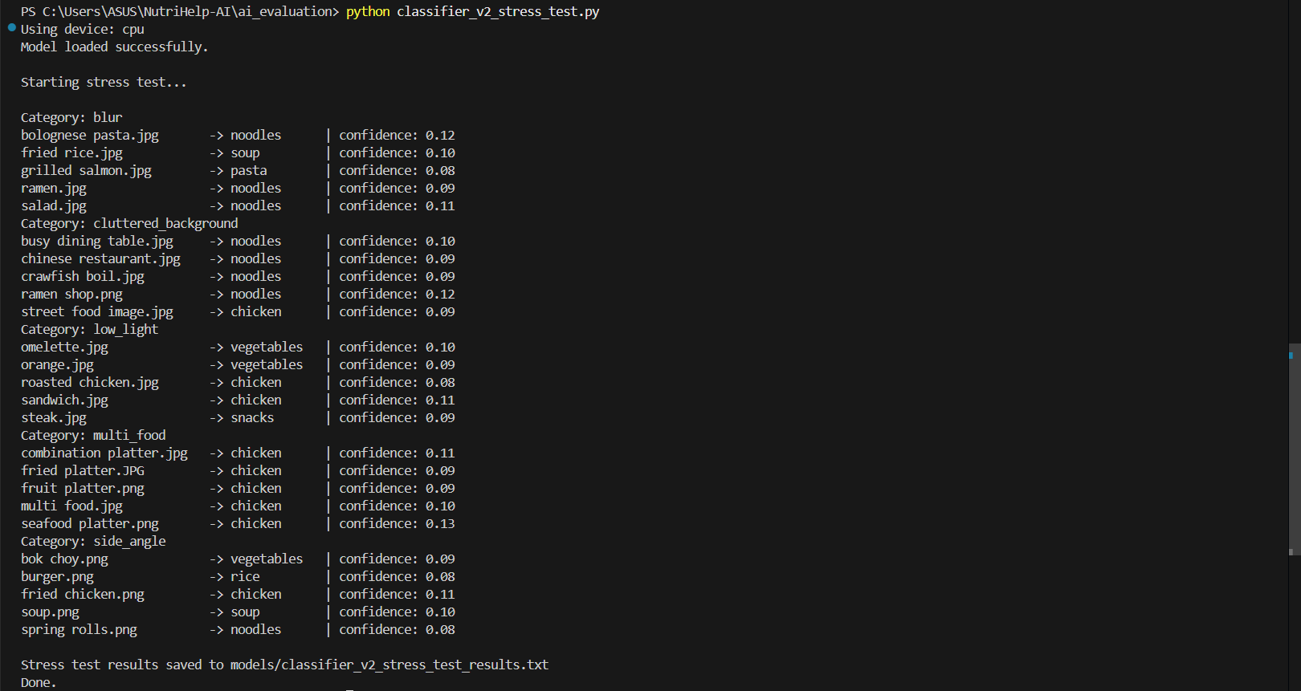
Across all five categories, the following patterns were consistently observed:
- Low confidence scores
Most predictions ranged between 0.08 and 0.13 confidence, indicating uncertainty in classification.
- Bias toward frequent classes
The model frequently predicted dominant categories such as chicken, noodles, or vegetables, especially in multi-food and cluttered scenes.
- Difficulty with multi-food images
Images containing multiple food items were often reduced to a single dominant prediction, ignoring secondary foods.
- Sensitivity to visual noise
Blur, low lighting, and non-standard angles significantly reduced prediction reliability.
These results confirm that while Classifier v2 is functional, it is not yet robust enough for uncontrolled real-world inputs.
9.4 Classifier Limitations Identified
Based on training and stress testing results, several key limitations were identified:
- Single-label classification constraint
The model can only predict one food class per image, which is insufficient for meals containing multiple food items.
- Dataset bias
Categories with more visually dominant features appear more frequently in predictions, suggesting imbalance in feature learning.
- Low confidence calibration
Even when predictions are correct, confidence scores remain low, reducing trustworthiness in downstream applications.
- Poor generalisation to non-ideal images
The classifier struggles with blurred images, cluttered environments, and side-angle shots that users are likely to upload.
These limitations are expected given dataset size and scope, and they align with the project’s junior-level development constraints.

10. Conclusion
The work completed in Weeks 6 and 7 demonstrates a clear progression from basic model training to deeper evaluation and critical analysis. Rather than focusing only on accuracy metrics, stress testing provided valuable insights into how the classifier behaves in realistic conditions.
Although Classifier v2 still has significant limitations, the results are meaningful and actionable. They provide a strong technical justification for future enhancements and ensure that next trimester’s work will be grounded in evidence rather than assumptions.
Overall, this phase successfully achieved its goal of understanding model behaviour, identifying weaknesses, and preparing a clear roadmap for future development.

